How to Download Files from Kreischer Miller’s Secure File Transfer

- Open the email received from LeapFILE Secure File Transfer Service.

- Click the link in the email under the FILE TRANSFER WAITING heading.
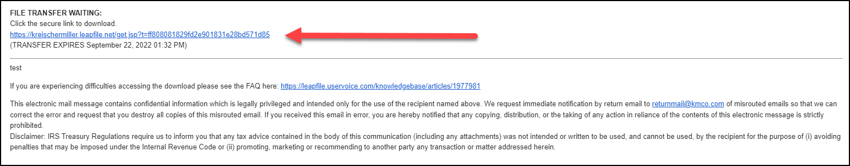
- Enter your email address then click the Authenticate button.
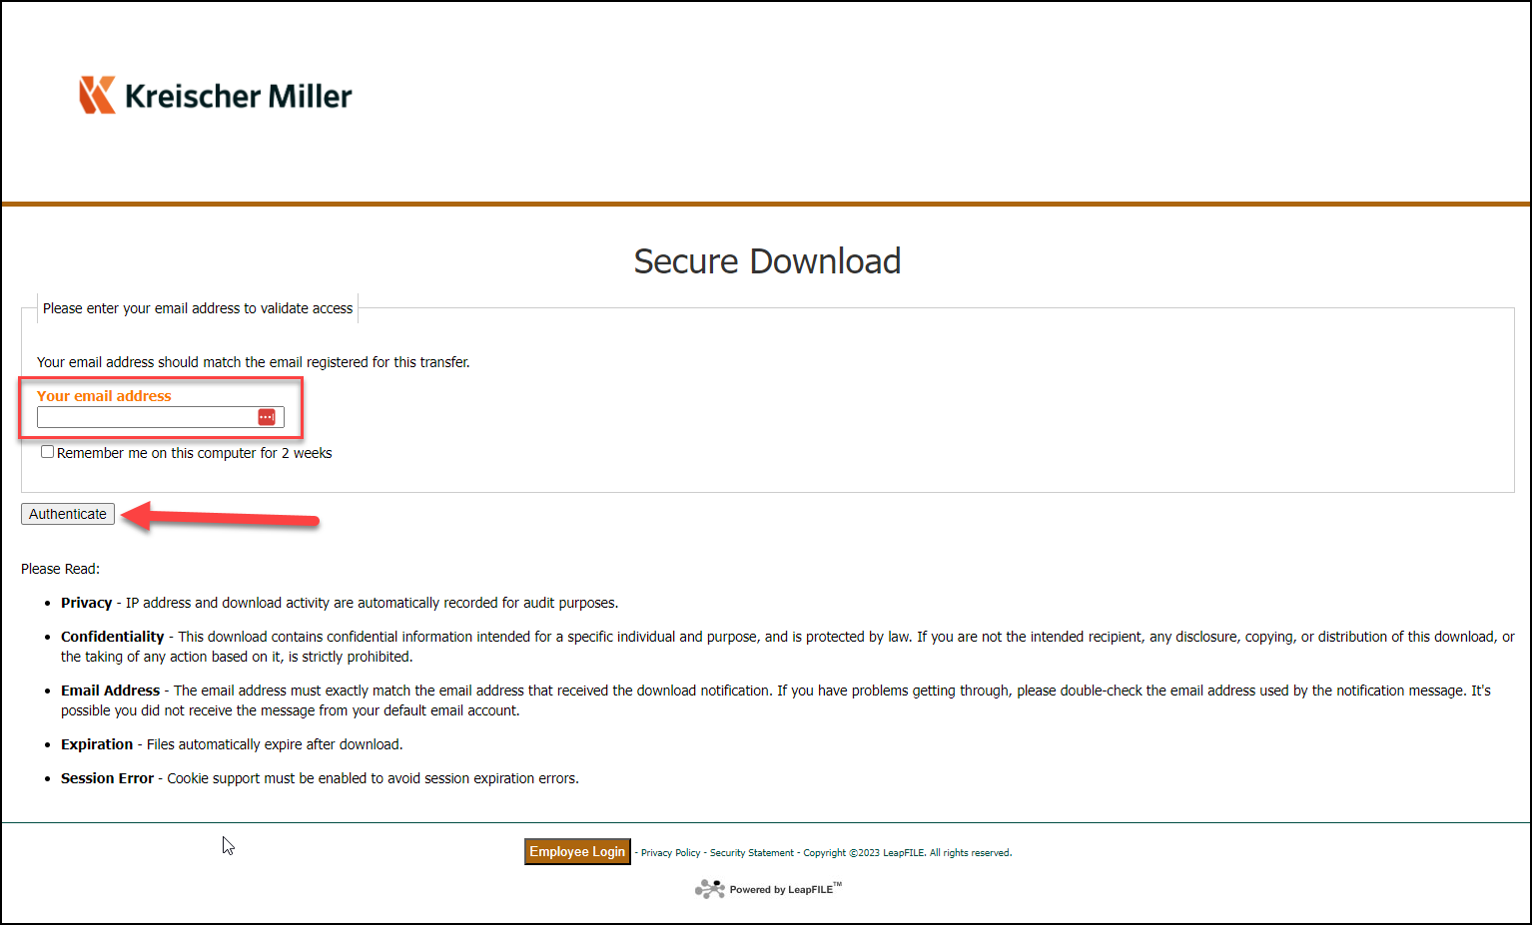
- Click the red Download button next to the file or files.
