How to Send Files to Kreischer Miller’s Secure File Transfer
- Navigate to www.kmco.com.
- Click on “Client Access” link at the top middle of the page.

- Under Secure File Transfer, click on the link to send files TO Kreischer Miller LLC
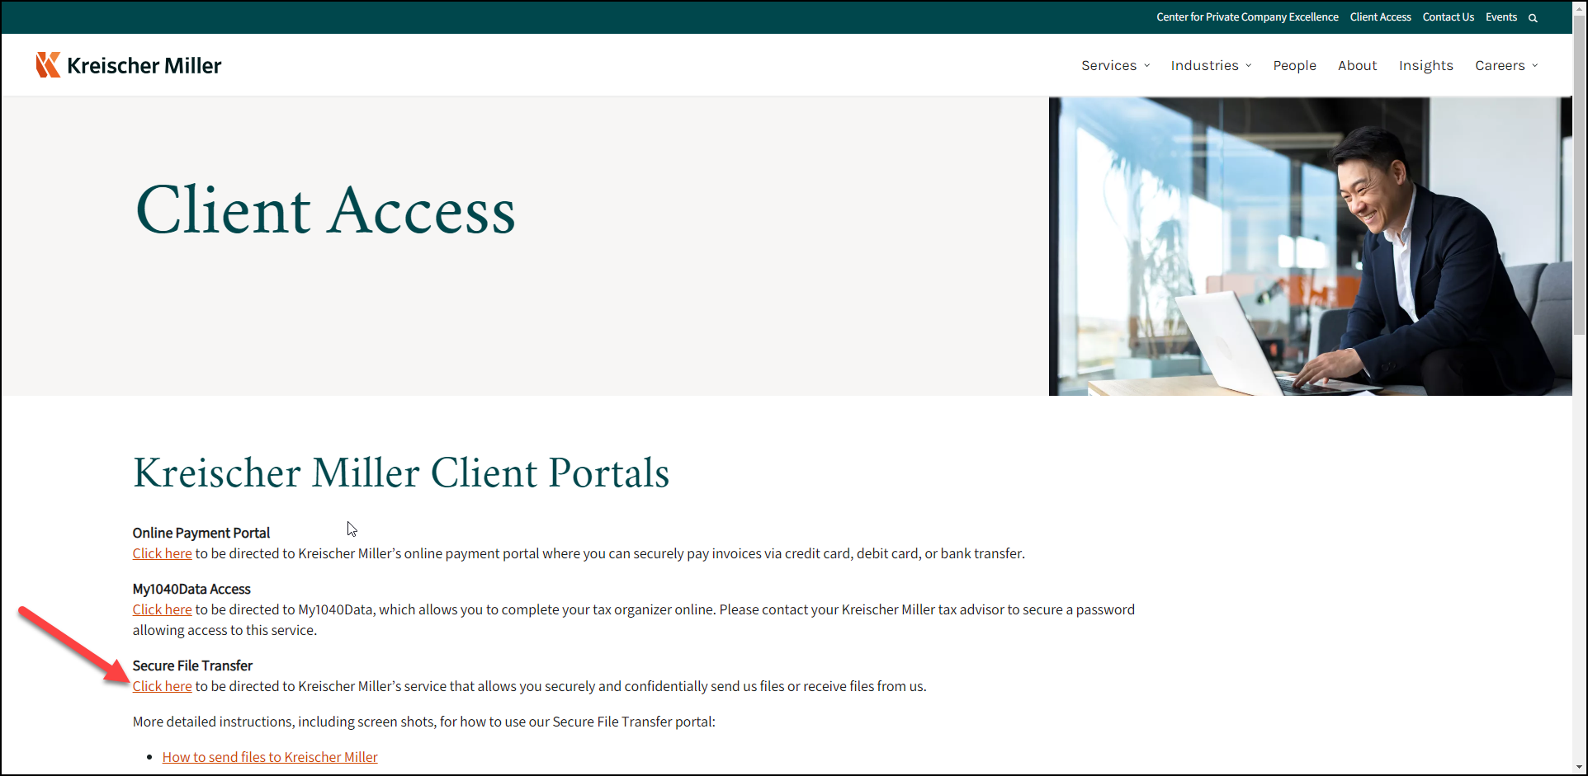
- Click on Secure Upload
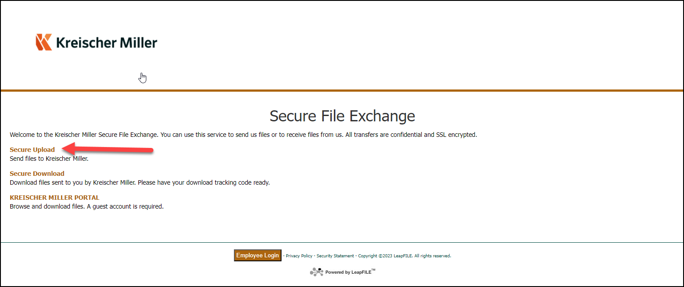
- Enter your name and email address
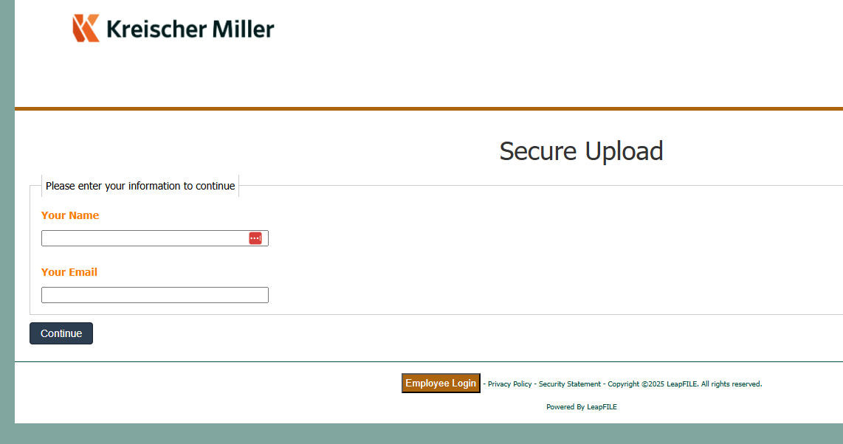
- A code will be sent to the email address you entered above, enter that code here (Note: This will only happen the first time you send a Leapfile to KM and then periodically when reverification is needed).
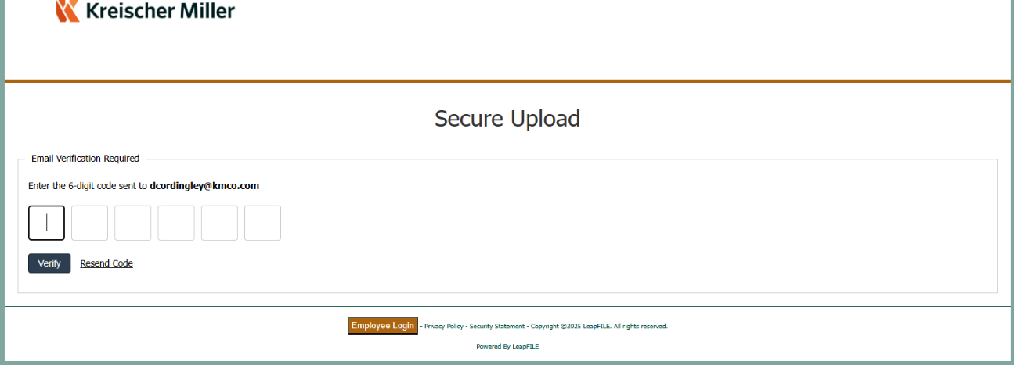
- Enter the KMCO employee’s email address and then click “Start” 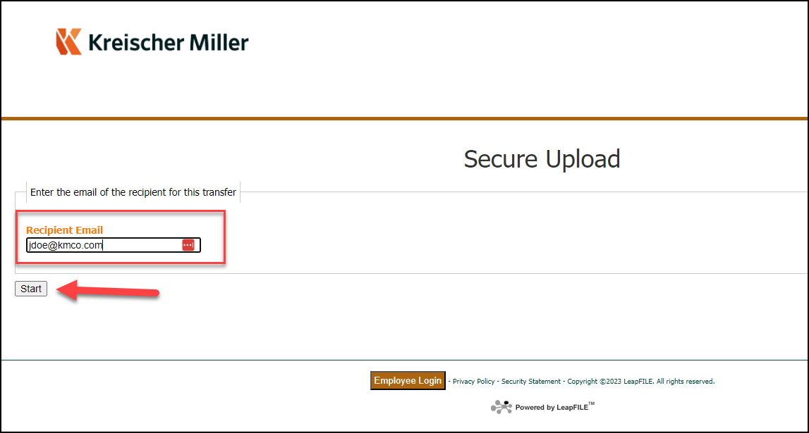

- Enter your (the client) information into the form and then click “select files and folders to send” via HTML5
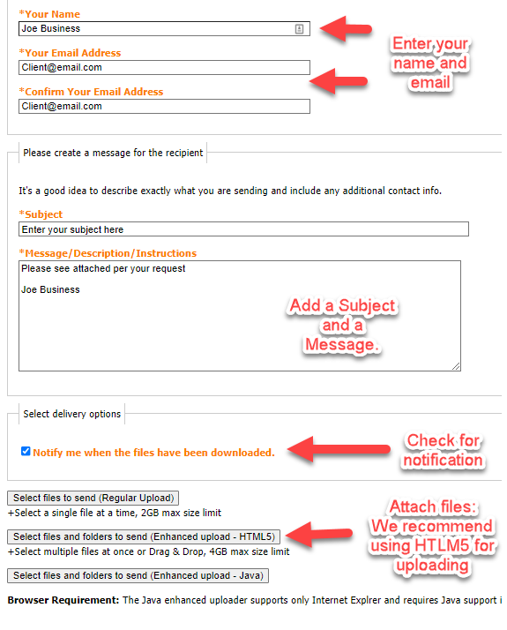

- Click “Choose Files” and select the file you want to send OR Drag and Drop from your dekstop and then click on Send
